

Electrical Engineering Student  
University of Wisconsin - Platteville  
woerpela@uwplatt.edu  
920-988-5872

920-9885872

Engineering Design Portfolio

Andrew Woerpel

# Contents

Internships……………………………………………………………......…………………………..2

Society of Automotive Engineers (SAE), Aero Design Team…………………… 6

Undergraduate Research………………………………………………………………………...9

School and Personal Projects…………………………………………………………………..11

Boy Scouts of America……………………………………………………………………………. 13

# http://www.spacefoundation.org/sites/default/files/articles/images/ORBITEC.pngOrbital Technologies Corporation (ORBITEC) Internship

|  |  |
| --- | --- |
| Position: | Electrical Engineering Intern |
| Duration: | Fall 2015 – present |
| Group Setting: | Mostly independent/small group |
| Responsibilities: | Assisting in many aspects of the final product development of flight fidelity microgravity greenhouse systems for NASA and other tasks. |

# http://www.nasa.gov/sites/default/files/veggie_steveswanson.jpgProject Work/Tasks

* Designed and documented custom cable assemblies
* Assembled, wired, and tested a hardware in the loop simulator for the Advanced Plant Habitat project
* Developed functional test procedures
* Developed detailed Test Work Instructions  
   for a subsystem control board

Astronaut Steve Swanson next to the ORBITEC designed Veggie plant growth system aboard the ISS. This system is the predecessor to the Advanced Plant Habitat which is slated to fly on SpX – 12 in late 2016.

* Transitioned part and circuit schematic libraries from DxDesigner to Altium Designer

# http://www.getfilings.com/sec-filings/130610/PLEXUS-CORP_8-K/pressreleasecooannoun_image1.jpgPlexus Corporation Internship

|  |  |
| --- | --- |
| Position: | Software/Product Engineering Intern |
| Duration: | Summer 2015 |
| Group Setting: | Worked in a team of 8 split between Neenah, WI and Boulder, CO. |
| Responsibilities: | Develop automated tests and the underlying framework to test product software. Develop a misuse test fixture for engineering confidence testing. |

# Continuous Integration Platform Software Development

Most of my time was spent creating and correcting C++ code for a continuous integration/ hardware-in-the-loop system that was used to test the functionality of a medical device while it was being developed. The code base was approximately 80,000 lines, consisting of over 300 independent tests ranging in length from 30 minutes to over 24 hours.

Notable Project Achievements

* Refactored widely used and complex segments of code that were causing intermittent failures due to telnet communication latency
* Identified and fixed inconsistencies between code and test procedures
* Improved message/debug logging to increase consistency and human readability
* Wrote a significant number of tests from scratch
* Fixed a large number of bugs

Tools and Techniques



* Agile software development method
* Tortoise SVN (software version control)
* Atlassian JIRA (issue tracking)
* JAMA (product development/requirement tracking)
* Atlassian Bamboo (continuous integration/code automation)

# Misuse Test Fixture

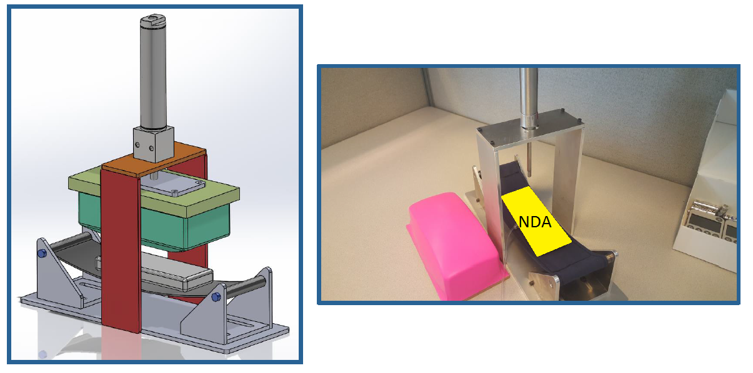A small portion of my time was spend designing a misuse test fixture for a medical device. The test fixture simulates someone putting the device in the back pocket of their pants and repeatedly sitting on it. I was responsible for the design of this fixture and even sewed the sling that the device sits in. The medical device is covered due to the confidentiality of the project.

Solid model of the test fixture beside the fully fabricated unit and silicone pad.

# Seljan Company Internship

|  |  |
| --- | --- |
| Position: | Mechanical Design Intern |
| Duration: | During College Breaks Summer 2013 – Winter 2015 |
| Group Setting: | Mostly Independent with occasional assistance from upper management and engineers |
| Responsibilities: | Every aspect of projects, from initial design to final implementation |



# Powder Coating Operation

|  |  |
| --- | --- |
| **Approximate Project Cost:** | $50,000 |
| **Project Length:** | 3 months |
| **Period:** | Summer 2013 |

For my first project as an intern at Seljan Company, I was tasked with setting up the infrastructure that would allow them to begin powder coating their products.

Project Details

* Researched process and obtained quotes from equipment and consumables suppliers
* Presented plan to upper management for approval
* Designed and built steam cleaning booth and mobile racking
* Lead team to assemble powder coating oven and powder application booth

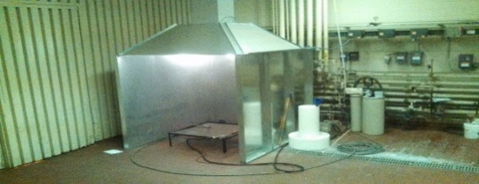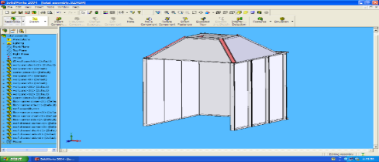

Solid model of steam booth and end result. The square ductwork leading to the ceiling is connected to an existing exhaust fan, for steam removal.

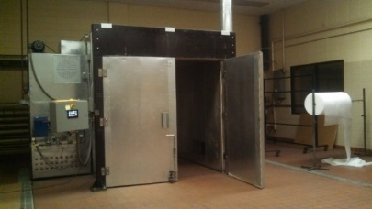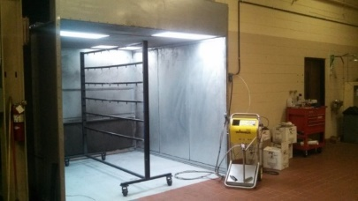

Images showing the 8’x10’x8’ powder coating oven, as well as the powder application booth, powder application gun, and adjustable cart.

# Conveyor System

|  |  |
| --- | --- |
| **Approximate Project Cost:** | $2,500 |
| **Project Length:** | 2 months |
| **Period:** | Summer 2014 |

For my second summer as an intern, I was in charge of creating a system that would remove metal stamping slugs from the back of several large punch presses. Prior to my arrival in the summer, Seljan Company had bought two used industrial quality conveyors, totaling around $5,000, with hopes of using them for this job. It was quickly determined that these were not adequate for this specific job since the slugs would get jammed in the chain drive system, causing the conveyor to stop. Instead of trying to modify these conveyors, I suggested that we build our own and promised that these would work better for this specific job than any commercially available system, and at a fraction of the cost. After some reluctance, I was allowed the opportunity to build a prototype of the conveyors that I had suggested.

Project Details

* Salvaged drive units from used conveyors
* Purchased required components
* Designed two custom conveyors to move slugs into recycling bin
* Assembled final units

Project Highlights

* Have been running almost continuously for over 1 year without breaking down
* Have moved approximately 100 tons of slugs

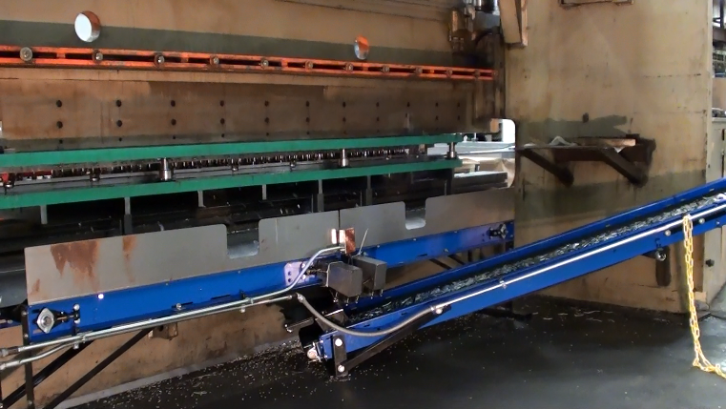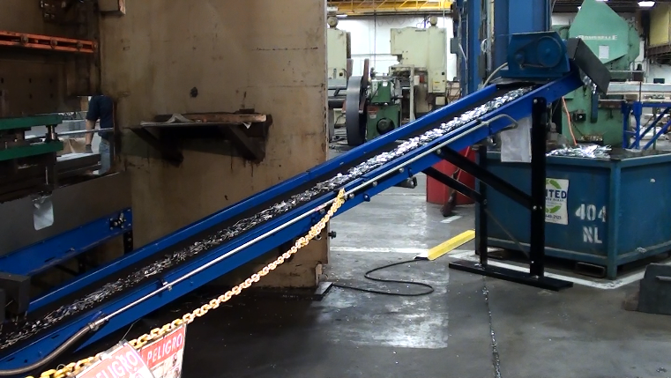

Shows the conveyor system removing slugs from the back of a 300 ton press break. Prior to the creating of this system, the slugs fell on the floor and were removed using scoop shovels.

# 

# Pallet Construction Operation

|  |  |
| --- | --- |
| **Project Length:** | 3 weeks |
| **Period:** | Winter 2013 |

Seljan Company had recently began producing specific parts in such volume that the cost of purchasing pallets from a supplier was becoming quite expensive. Therefore, over winter break I was tasked with creating a process and the equipment necessary to construct these specific pallets. I designed and built an adjustable assembly fixture, a saw table with easily adjustable end stop, and saw horses for this project.

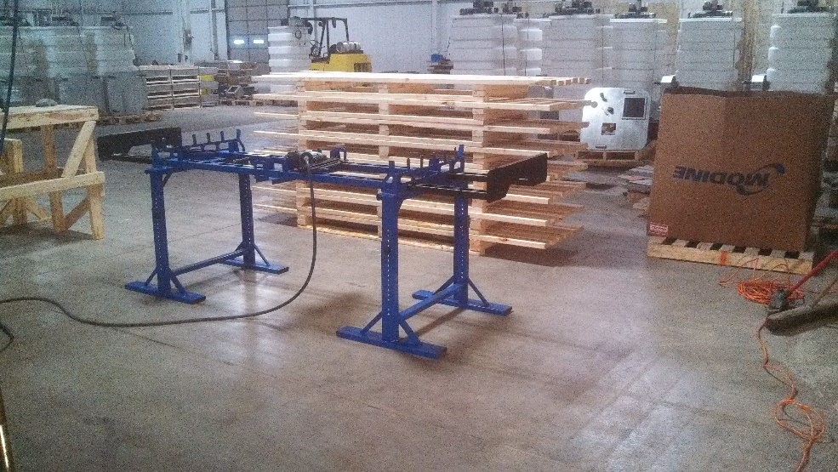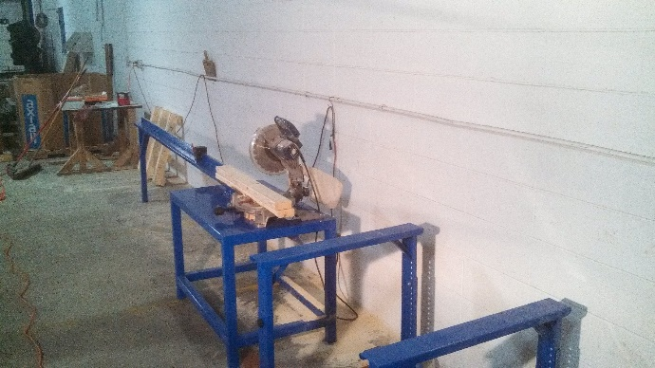

Shows the pallet assembly fixture and finished pallets, as well as the lumber sawing station.

# Society of Automotive Engineers (SAE), Aero Design Team

|  |  |
| --- | --- |
| Position: | Electrical Engineer |
| Duration: | Fall 2014 - Present |
| Group Setting: | Work as a team with freshman EE student |
| Responsibilities: | Project management, communication with team, hardware/software design and construction |

SAE Aero is an international collegiate design competition centered around the design and construction of an aircraft that is able to complete a specific mission. In the spring 2015, our team competed in the Regular Class competition which has a goal of lifting the largest payload possible. Our aircraft, which only weighed about 9 lbs, was able to carry a static payload of 17lbs.

# Automated Motor/Propeller Test Stand

|  |  |
| --- | --- |
| **Project Length:** | 4 months |
| **Period:** | Fall 2014 |

A fully automated test stand was developed by myself and another teammate classify motor and propeller combinations that would produce the greatest thrust while staying below the maximum power consumption limit (1000W) that was defined by the competition. In addition to static benchtop tests, we attached the test stand to the top of a car in order to characterize the dynamic properties of each propulsion system.

Project Contributions

* Designed and built test stand from laser-cut and bent sheet metal
* Designed circuitry that allows a Teensy 3.1 microcontroller to measure instantaneous current, voltage, thrust, and motor speed.
* Wrote program in Python to
  + Initialize the test stand
  + Send data acquisition commands
  + Send motor control commands based on scratch built PID controller
  + Scale, store, and display the results of a test

Shows the test stand (powder coated UW – Platteville colors) and the strain gauge used to measure thrust.

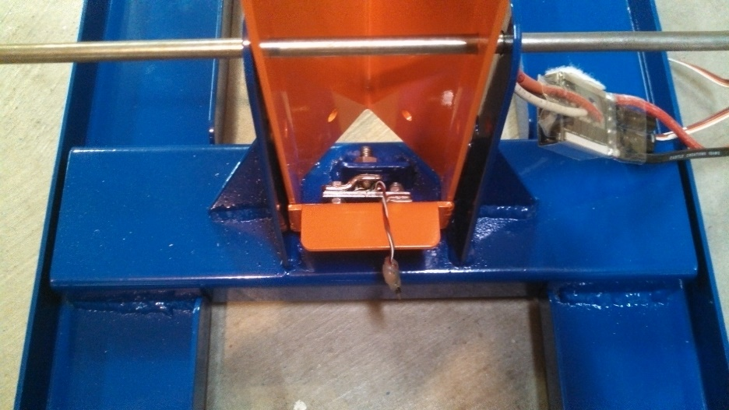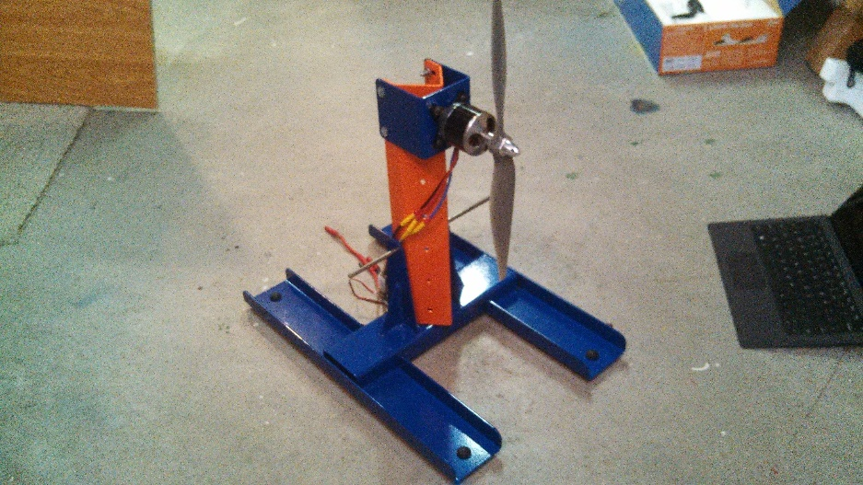

**Early Test Stand Development Video:** <https://www.youtube.com/watch?v=-mOnRbxfxIw>

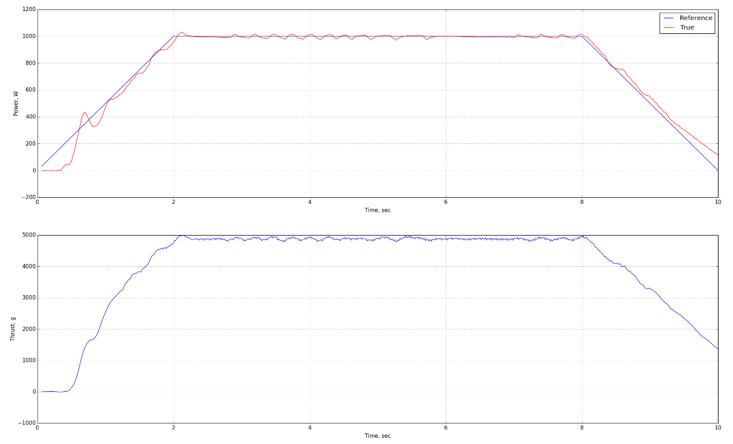

Image of the plots that are generated by the SAE test stand.

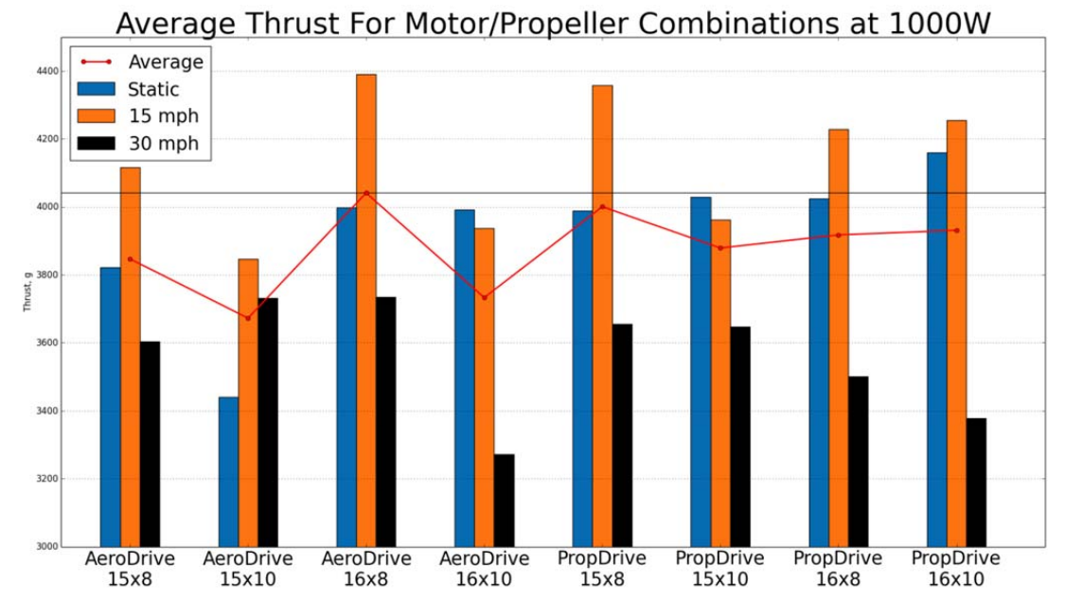

Bar graph showing average thrust for different props/motors at 1000W and different airspeeds.

# Flight Power System Controller

|  |  |
| --- | --- |
| **Project Length:** | 1 month |
| **Period:** | Spring 2015 |

In order to ensure that our aircraft fully utilized its power system without exceeding the 1000 W competition mandated power limit, I developed a closed loop controller to manage the throttle while the aircraft is in flight. The system consisted of a Teensy 3.1 microcontroller, power sensing circuitry, and a custom PCB. I was the sole developer of this system with the exception of some PBC layout.

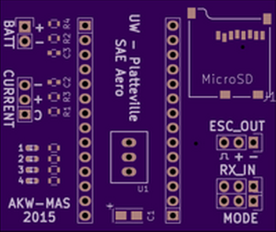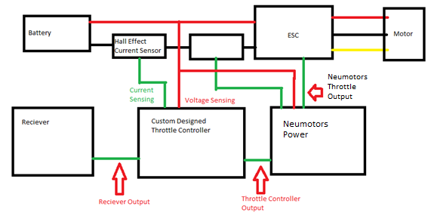

Shows a block diagram of the complete flight hardware system including the power system controller (left). Custom PCB for the controller (right).

# Undergraduate Research in Microsystems & Nanotechnology

|  |  |
| --- | --- |
| Duration: | Spring 2014 - Present |
| Group Setting: | Mostly independent with some guidance from my faculty advisor and the lab manager |
| Responsibilities: | Designing, conducting, and analyzing tests on samples |

My involvement in undergraduate research began when I approached one of my professors about partaking in such an opportunity. She tasked me with refining a procedure for creating nanostructures using a process called nanosphere lithography. After working on this project for a year with encouraging results, I changed the focus of my research to the fabrication of graphene nanotransistors using electron beam lithography.

**My research with nanosphere lithography was selected to represent the University of Wisconsin – Platteville at an event called “Posters in the Rotunda” in April of 2015 at the state capitol building in Madison, Wisconsin. At this event (pictured above), I had the opportunity to show my research to state legislators, University of Wisconsin System leaders, Students, and Alumni.**

# Nanosphere Lithography

|  |  |
| --- | --- |
| **Project Length:** | 1 Year |
| **Period:** | Spring – Fall 2014 |
|  |  |

The basic steps for this type of lithography are as follows.

* Clean substrate
* Spin coat 1 µm (or smaller) spheres on surface of substrate
* Deposit metal over substrate using the spheres as a mask
* 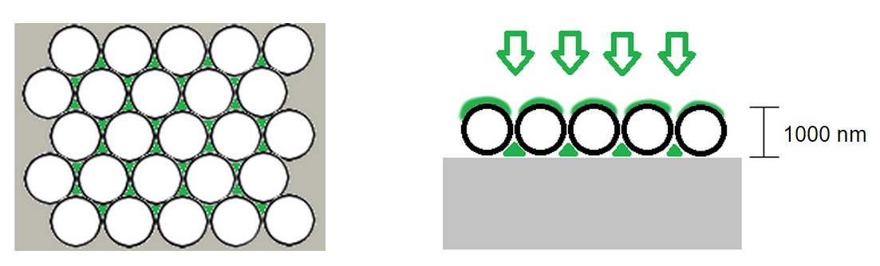Remove spheres from surface to expose nanostructures

Shows illustration of sphere arrays on surface, and the areas where the deposited metal (green) adheres to the substrate (left). A cross-section view of metal deposition is shown on the right.

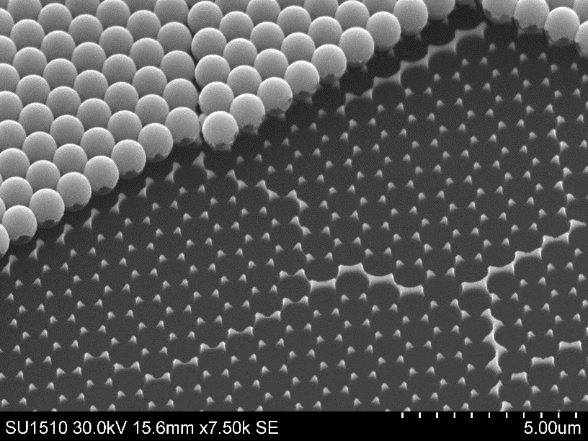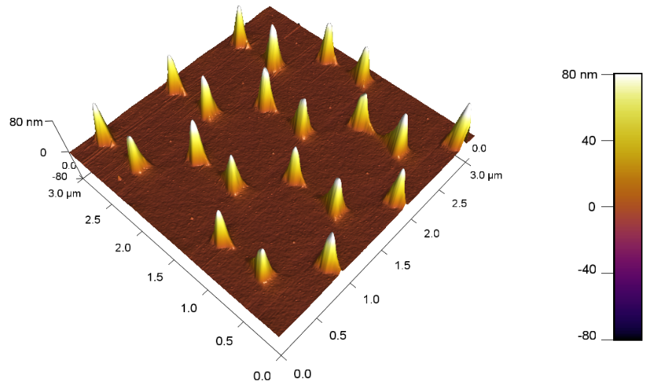

Shows a scanning electron microscope image of the boundary of where spheres were removed. The nanostructures that are left are approximately 200 nm across (left). Shows a 3D atomic force microscope generated image of several nanostructures (right).

# School and Personal Projects

# N-Body Physics Simulation

|  |  |
| --- | --- |
| **Project Type:** | Personal |

As an interesting project and a cool challenge, I created a computer program that could simulate the interactions of planetary bodies exclusively under the force of their mutual gravitation attraction. The simulation begins by spawning a number of particles (I have used as many as 100) with random masses, positions, and velocities. It then uses basic Newtonian mechanics in order to calculate each time step. I began by creating the simulation in 2D and have since expanded it to 3D. The simulation consists of C++ code that carries out all of the calculations, and a Python script to do all of the post processing and animation creation.

Challenges:

* Properly handling collisions. Forces tend towards infinity when the particles get very close.
* Keeping meaningful interactions in the frame while excluding particles that are being ejected from the main group
* Adequately representing the position of particles in 3D simulations. It can look like a bit of a mess with too many particles.

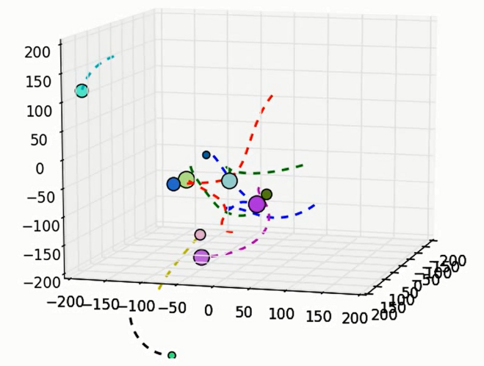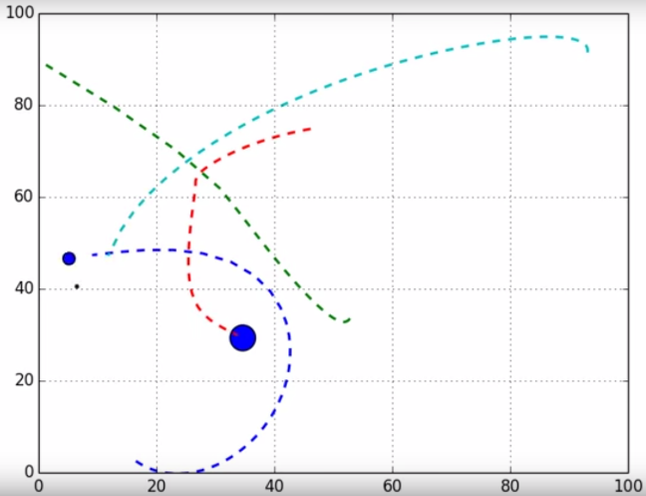



Playlist of several simulations in various stages of development: <https://www.youtube.com/playlist?list=PLZQMk6hP4uXKo1d4sAOJXfnoL6wv1Wzs1>

# Line Recognition Software

|  |  |
| --- | --- |
| **Project Type:** | Personal |

I began working on this project after coming up the idea that an autonomous vehicle could possibly determine its position in space based on its distance from unchanging, and easily recognizable features that it has seen before. I thought a good place to start was to create some software that could take an image and process it in order to find many straight lines within an image. To do this, I take a picture using a USB webcam connected to a BeagleBone Black (a single board Linux computer). The image is then run though a Canny Edge detection algorithm using the Python openCV library to produce an image like the one on the left below. Then I wrote a Python script to go through the image and pick out the edges that are associated with straight lines. While it is far from perfect, when the settings are correctly chosen, the results are quite good.

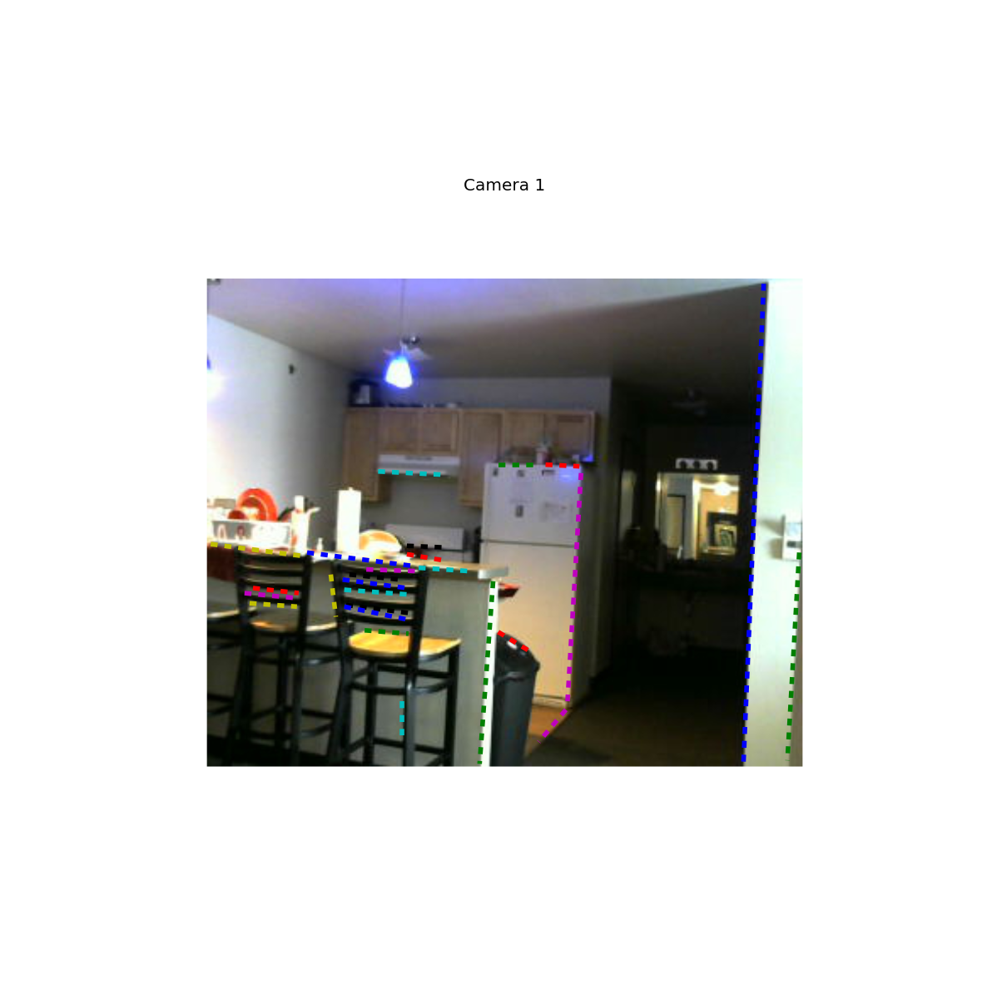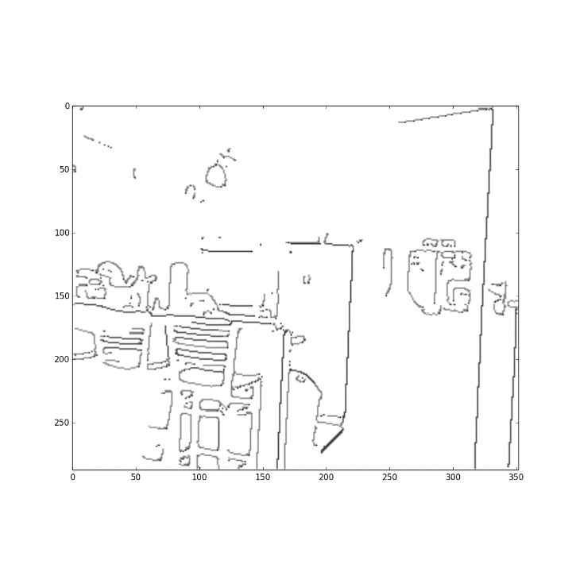

# FPGA Stepper Motor Driver

|  |  |
| --- | --- |
| **Project Type:** | School |

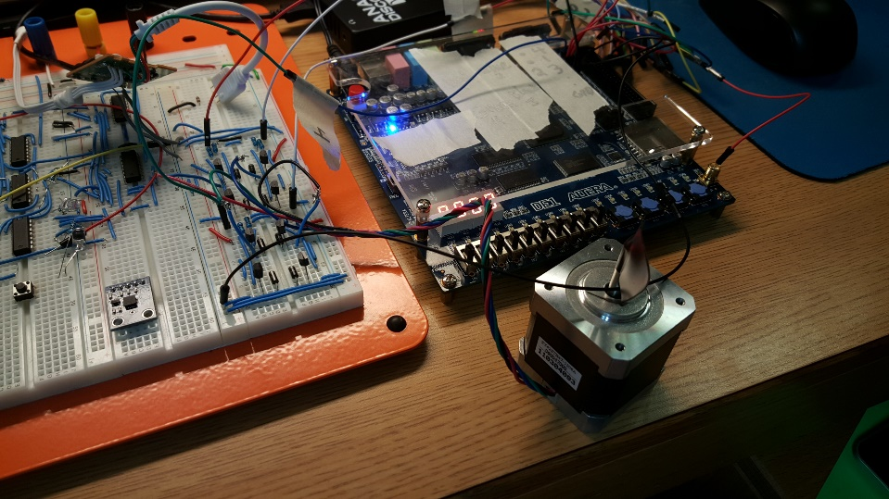The final project for a digital electronics course that I took in spring of 2015 was to create something using an Altera FPGA development board. I chose to make a stepper motor driver because of the challenge that it would present and the satisfaction I would get from seeing the motor spin. The main challenge from the project came from my lack of experience creating any of the components that were required. I had never used Verilog, built the necessary drive circuitry (2 H-Bridges), or worked with bipolar stepper motors. In the end, the project was very successful and educational.

Video (Warning: I sound super bland in this video):

<https://www.youtube.com/watch?v=1Pugp-vHnKc>

# Boy Scouts of America

|  |  |
| --- | --- |
| Positions: | Senior Patrol leader,  Assistant Senior Patrol Leader,  Instructor |
| Duration: | 2001 - 2012 |
| Group Setting: | Mostly worked in teams and small groups |

# Eagle Scout Service Project

|  |  |
| --- | --- |
| **Project Length:** | 5 Months |
| **Period:** | Spring 2010 |

For my Eagle Scout project, a group of volunteers and I built a 33 ft long ladder bridge over a small ravine at my local mountain biking trails. I designed the bridge in SolidWorks, raised the needed capital, and then lead a team to construct and install the bridge at the site. Two bridge sections of approximately 15 ft each and were mounted on top of cast concrete footings weighing approximately 1200 lbs. In total, the project took 148 man-hours of effort from volunteers and myself.

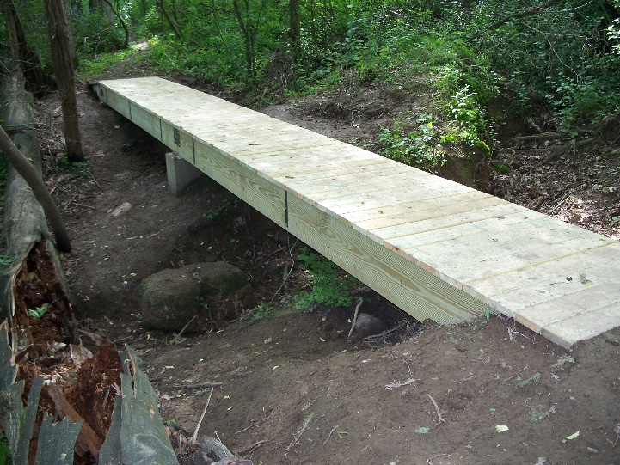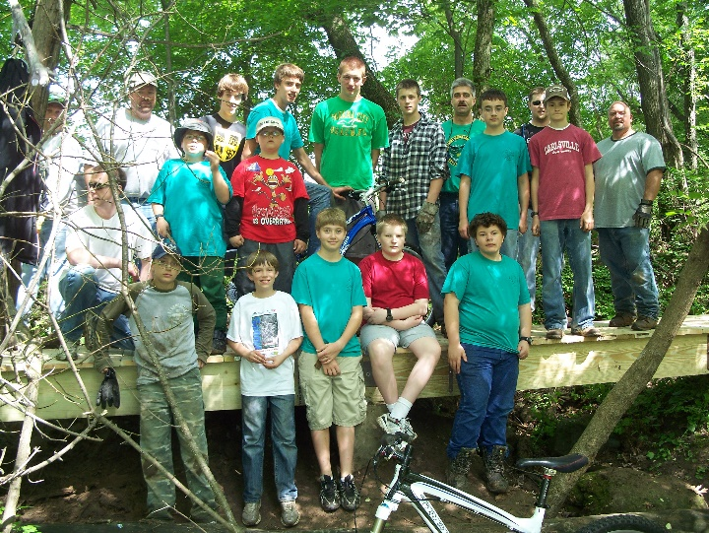

Shows images of the bridge and the team the helped me complete the project.